**IELTS TEST**

**Topics:**

1. Introduction of IELTS

2. Types of IELTS

3. Breakdown of all the sections of IELTS (Listening, reading, writing, speaking)

4. sample

**Objective:**

* Provide students with a way to train themselves in a variety of entrance exam IELTS is one of them.
* Preparing students for IELTS.

1. **Introduction**

The International English Language Testing System (IELTS) measures the language proficiency of those who wish to study or work where English is used as the language of communication. It uses a nine-band scale to clearly identify capacity levels ranging from non-speaker (band score 1) to expert (band score 9).

1. **Types of IELTS**

Aspirant can prepare for two types of IELTS exam depends on his/her purpose to appear for the same.

1. IELTS for academics
2. IELTS for general training

**IELTS Academics**

The IELTS Academic Examination is for those who have applied for higher education or professional registration in an English-speaking environment. It reflects certain characteristics of the academic language and assesses whether you are ready to begin study or training.

**IELTS General training**

Aspirants who wish to go for the Secondary education, work experience or training program to a country which is having English as a primary language. This is also important for the migration to Australia, Canada, New Zealand and UK. IELTS general trainings centre of attention is basic survival skills in broad social & workplace conditions.

**IELTS is available at more than 1,600 locations worldwide, including more than 50 locations in the USA.**

**3. Breakdown of all the sections of IELTS (Listening, reading, writing, speaking)**

Both versions of IELTS provide a valid and accurate assessment of the four language skills: listening, reading, writing, and speaking.

Test format:

As we know there are two types of IELTS, academic and general. Both tests check the proficiency of candidate in English considering the four sections namely as: speaking, listening, reading, and writing.

Pattern for the listening and speaking are the same for both the versions of IELTS but it varies for the reading and writing depend on the test because it focuses on subject matter.

Duration of the test:

Aspirants listening, reading, and writing will be conducted on the same day. No breaks in between.

However, speaking section can be conducted one week before or after the remaining sections.

Test centres will guide candidate accordingly.

**IELTS test require total time as 2hr 45 min.**

**3.1 Listening**

**Duration of the test: 30 min**

Aspirants need to listen 4 recordings of the native English speakers. Depend on the recording there will be set of question which aspirant need to answer.

Aspirant can expect the recording as follows:

* Recording 1: general conversation between two people depends on day to day life.
* Recording 2: a sermon about social life. (a monologue)
* Recording 3: a conversation between more than two people it expands up to 4 persons. Which mostly depend on education and training.
* Recording 4: It will be a monologue based on academic subject. It can be a any professor lecture.

Assessors are checking for aspirant’s ability to understand the idea and purpose of the speaker, their ability to pursue information and ability to develop an idea based on it.

**IELTS listening description**

|  |  |
| --- | --- |
| **Format** | **Total 3 parts as mention below:**   * Recording 1: general conversation between two people depends on day to day life. * Recording 2: a sermon about social life. (a monologue) * Recording 3: a conversation between more than two people it expands up to 4 persons. Which mostly depend on education and training.   Each part consists of 10 questions each.  Aspirant can hear the recording only once. |
| **Time** | Approximately 30 min. (Extra 10 minutes transfer time will be given) |
| **No. of questions** | 40 |
| **Task** | Listening test consist of variety of questions including:  Multiple choice questions  Sentence completion questions  Match the following  Map/plan/diagram labelling  Table/flow chart/note completion  Do not forget poor grammar & spellings are penalized. |
| **Answer** | Once aspirants done with the recordings, they will get 10 min. totransfer their answers into the main sheet. |
| **Mark** | Each question carries one mark.  At the last 40 questions score will be converted into IELTS 9 band. |

**3.2 Speaking**

**Duration of the test: 10-15 min.**

In this test assessor is going to check aspirants spoken English. Everything is recorded for evaluation purpose.

**Speaking consist of three parts.**

* **Part 1:** Overall Interview (Questions will be based on Your introduction, friends and family, aspirant’s area of interest).
* **Part 2**: Long turn (Aspirant will get one task card on which he/she need to speak for 2 min. aspirant need to cover all the points which are mention on the card. After that evaluator will ask some questions based on it. Aspirant will get 1 min. to prepare for the topic along with pen and paper to make a note.
* **Part 3:** Discussion (aspirant need to brief the topic which was given to him/her in the last round evaluator and aspirant need to discuss it)

**IELTS Speaking description**

|  |  |
| --- | --- |
| **Format** | Speaking test is nothing but an interaction between the aspirant and evaluator to check his/her spoken English ability. |
| **Time** | 10-15 min |
| **Task** | Speaking test consist of three parts as discussed above |

**3.3 Reading**

**Duration of the test: 60 min**

Reading section of the IELTS will be different for General training and academics.

**IELTS general training reading description:**

|  |  |
| --- | --- |
| **Format** | Section 1: 2-3 short texts  Section 2: 2 texts  Section 3: 1 long text |
| **Time** | 60 min |
| **No of questions** | 40 |
| **Type of questions** | **Aspirant can expect the questions based on:**  MCQ  Sentence completion  Identifying idea of the writer  Matching  Short answer question |
| **Sources** | Section 1: texts based on social survival  Section 2: workplace survival  Section 3: general reading (text can be from newspaper, magazine, fictional and non-fictional books) |
| **Answer** | No extra time will be given to transfer the answers in main sheet.  Poor spellings and grammar are penalized. |
| **Mark** | Each question carries one mark  At the last 40 questions score will be converted into IELTS 9 band. |

**IELTS Academic reading description:**

|  |  |
| --- | --- |
| **Format** | Three passage consist of variety of questions and task type. |
| **Time** | 60 min |
| **No of questions** | 40 |
| **Type of questions** | **Aspirant can expect the questions based on:**  MCQ  Sentence completion  Identifying idea of the writer  Matching  Short answer question |
| **Sources** | Text can be from newspaper, magazine, fictional and non-fictional books for non-specialist aspirants. All are based on general interest. |
| **Answer** | No extra time will be given to transfer the answers in main sheet.  Poor spellings and grammar are penalized. |
| **Mark** | Each question carries one mark  At the last 40 questions score will be converted into IELTS 9 band**.** |

**3.4 Writing**

**Duration of the test: 60 min**

Writing section of the IELTS will be different for General training and academics.

**IELTS academic writing description:**

Given topics will vary from general topic to the topics which are important for the aspirant to enrol themselves to undergraduate or postgraduate courses.

**There will be two tasks in the writing section.**

**Task 1:** Task will be based on data interpretation. A diagram, chart, table or graph will be given to aspirant. Aspirant needs to explain the same in his/her own words.

**Task 2:** Aspirant needs to write an easy in formal style in response of argument, point of view or problem.

|  |  |
| --- | --- |
| **Format** | Aspirants need to finish two writing tasks. Both are compulsory |
| **Time** | 60 min |
| **No. of questions** | 2 |
| **Task** | **Task 1:** 20 min (150 words)  **Task 2:** 40 min (250 words) |
| **Answers** | Notes and bullet points are not considered as an answer. Everything should be written as full. |

**IELTS general training writing description:**

In IELTS general training writing section task will be based on general interest.

**Task 1:** aspirant needs to write a letter base on a given scenario. Letter can be formal, informal, or personal.

**Task 2:** Aspirant needs to write an easy in formal style in response of argument, point of view or problem. Essay can be personal in style.

|  |  |
| --- | --- |
| **Format** | Aspirants need to finish two writing tasks. Both are compulsory |
| **Time** | 60 min |
| **No. of questions** | **2** |
| **Task** | **Task 1:** letter writing  **Task 2:** easy writing |
| **Answers** | Notes and bullet points are not considered as an answer. Everything should be written as full. |

**4. Sample**

**4.1 Speaking test:**

This will be same for IELTS academics and general training

Let’s check one transcript of the same:

**Part 1 Introduction and Interview**

[This part of the test begins with the examiner introducing himself or herself and

checking the candidate’s identification. It then continues as an interview.]

**Examiner:** Now, in this first part, I’d like to ask you some more questions about

yourself, OK?

Let’s talk about your hometown or village. What kind of place is it?

**Candidate needs to answer.**

**Examiner:** What’s the most interesting part of this place ... village?

**Candidate needs to answer.**

**Examiner:** What kind of jobs do people in the village do?

**Candidate needs to answer.**

**Examiner:** Would you say it’s a good place to live?

**Candidate needs to answer.**

**Examiner:** Let’s move on to talk about accommodation. Tell me about the kind of

accommodation you live in ...

**Candidate needs to answer.**

**Part 2 Individual long turn**

The candidate will be asked to speak about a particular topic. The candidate will have 1 minute to prepare before speaking for a maximum of 2 minutes. The examiner will then ask one or two questions on the same topic to finish this part of the test.

**Examiner:** Alright? Remember you have one to two minutes for this, so don’t worry if I stop you. I’ll tell you when the time is up.

**Candidate:** OK

**Examiner:** Can you start speaking now, please?

**Candidate:** Yes. One of the most important things I have is my piano because I like playing the piano. I got it from my parents to my 12th birthday, so I have it for about

nine years, and the reason why it is so important for me is that I can go into another world when I’m playing piano. I can forget what’s around me and what ...

I can forget my problems, and this is sometimes quite good for a few minutes. Or I can play to relax or just, yes to … to relax and to think of something completely different.

**Examiner:** Thank you. Would it be easy to replace this, this piano?

**Candidate:** Yes, I think it wouldn’t be that big problem, but I like my piano as it is because I have it from my parents, it’s some kind unique for me.

**Part 3 Two-way discussion (long turn)**

The candidate will be asked further questions connected to the topic in Part 2. These questions will provide the candidate with an opportunity to discuss more abstract ideas and issues. It lasts between 4 and 5 minutes.

**4.2 Writing test**

**Task-1**

In the first part, candidates are given a task based on some graphic or pictorial documents. They are required to write a descriptive report of at least 150 words on the pictorial.

Answers could vary based on the nature of a graph or diagram. The type of language will vary, but there is a certain structure they will all follow.

The candidate must begin with one or two sentences that state what the IELTS writing task 1 shows. The title of the graph needs to be paraphrased along with a time frame if there is any. The candidate also must mention the main trends in the graph. There is no need to give any details. More specific details need to be given in the body paragraphs

Let’s take this example:

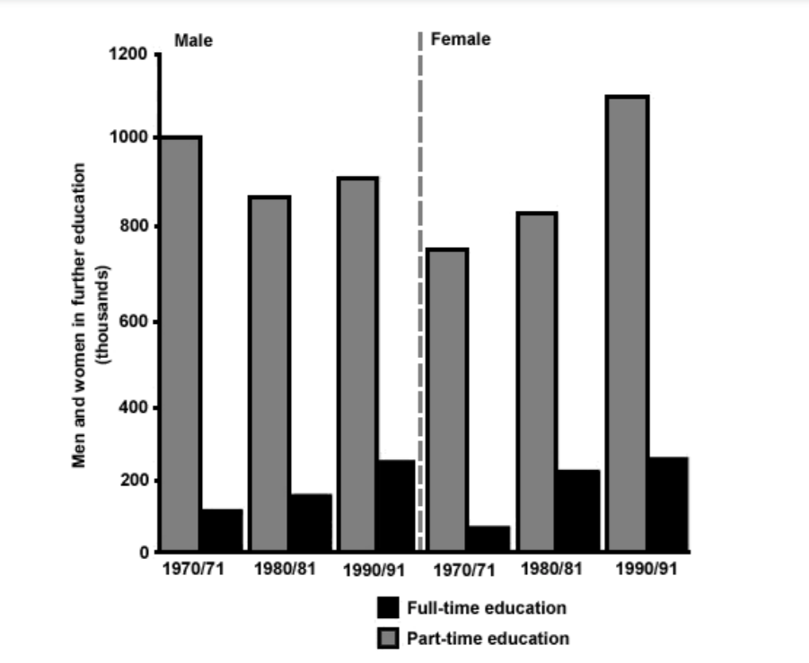

**Task-2**

You should spend about 40 minutes on this task.

Write about the following topic:

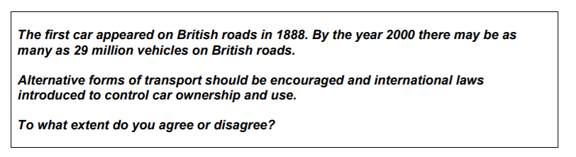

**References**

1. Sanjay Kumar, Pushpa Lata. Communication skills. Oxford higher education.
2. P. Subba Rao, B. Anita Kumar, C. Hima Bindu. Technical Communication Skill. CENGAGE Learning.